TERM II
- Components of the environment soil
- Heat energy
- Occupants in our community, crop growing
- Bacteria and Fungi

TERM III 2013
- Types of changes – Biological, Physical and Chemical changes
- Keeping Goats, Sheep and Pigs
- Food and Nutrition
- Primary Health Care (PHC)

COMPONENTS OF THE ENVIRONMENT:
WEEK 1
LESSON 1
SOIL
Soil is a continuous layer that covers the earth’s surface.
Or
Soil is a medium in which plants grow and get water and mineral salts.

HOW SOIL IS FORMED
  - By weathering
  - By decomposition of organic matter.

Weathering is the physical and chemical breakdown of rocks into small particles to form soil.
Decomposition is the rotting of dead organic matter.

TYPES OF SOIL
There are three types of soil
- Clay soil.
- Loam soil.
- Sandy soil.
- CLAY SOIL
Characteristics of clay soil
- It has fine particles.
- It has closely packed particles.
- It does not allow water to pass through it very fast.
- It has a high water retention capacity so it easily becomes water logged.
- Clay soil has the highest rate of capillarity
Importance of clay soil
  - Clay soil is good for pottery work (making pots, ceramics and modeling).
  - Clay soil is good for making bricks for building.
  - Clay soil is good for making tiles for roofing.
Illustration of arrangement of particles in clay soil.
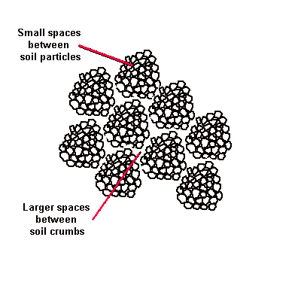
Activity
  - What is soil?
  - Identify any three components of soil.
  - How is soil formed?
  - Mention the three types of soil.
  - How is clay useful to man?
LESSON 2
- LOAM SOIL
Loam soil is a mixture of clay soil and organic matter
Organic matter (humus) consists of decayed plants and animal matter
Loam soil usually has adequate water, air and humus to sustain plant growth.
Characteristics of loam soil.
- It’s particles are fairly arranged
- It contains both clay and sand particles.
- It has a lot of humus for plant growth.
- Has fairly larger air spaces as compared to clay soil
Importance of loam soil
  - It is good for crop growing.
Illustration of arrangement of particles in loam soil.
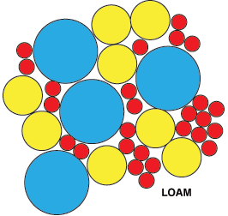

1. Why is loam soil the best for plant growth?
- It contains a lot of humus.
- It contains balanced particles of sand and clay.
- SANDY SOIL
Illustration of arrangement of particles in sandy soil.
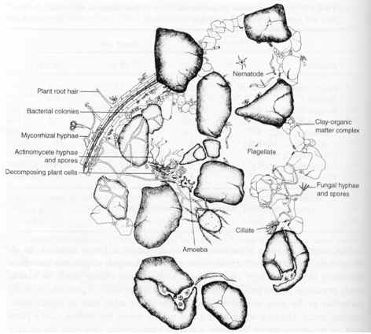
- Has large particles that make it to be well aerated
- Water passes through it easily
- Has poor water retention capacity
- Has high water drainage
- It is easy to dig
- Has a poor rate of capillarity
Capillarity is the up take of water through the soil particles. /
Capillarity is the tendency of water to rise through small narrow spaces.
Drainage is the capacity of the soil to allow water to pass through it.
Importance of sandy soil.
- Used for building.
- Used for making glass and sand papers.
Nb.It is not good for crop growing because it has a low water holding capacity.
Activity
- why is loam soil the best for crop growing?
- mention one characteristic of loam soil
- identify the type of soil which used for making glass.
- what is capillarity?
- which type of soil is porous?
LESSON 3
COMPONENTS OF THE SOIL
These are things which make up soil, they include:
- Air.
- water
- humus
- rock particles
- living organisms eg bacteria, insects, earthworms etc.
Importance of components of soil
- Air
- Air is used by animals in the soil to respire
- Air is used during germination.
- Water
- Water is used by plants for germination
- Making starch (it is a raw material for photosynthesis)
- Promoting decay of matter
- Rock particles ( inorganic materials like: sand, gravels, clay formed by weathering)
- Provide space for air to occupy
- Humus – dead decayed plants and animal matter
- Provide plant nutrients.
- Improve soil fertility
- Makes the soil appear dark in colour
- Living organisms
Examples of animals that live in the soil.
Bacteria, moles, porcupines, earth worms and ants
- Bacteria like nitrogen fixing bacteria fix nitrogen in the soil and hence improving on soil fertility.
Earthworms
- Aerate the soil.
- Softens the soil /plough the soil
- Add soil fertility by breaking down dead plants and animal remains.
NB: Why do you think earthworms come out of the soil after raining?
- To breathe /take in oxygen.

PROPERTIES OF SOIL.
- It has air.
- It has water.
- It contains mineral salts.
- EXPERIMENT ABOUT SOIL CONTAINS AIR.

SOIL PROFILE
Is the vertical arrangement of soil layers.
Or
Arrangement of soil layers from top to bottom.
Areas where one can clearly see soil profile.
- Pit latrines. – In trenches.

Illustration of the layers of the soil.
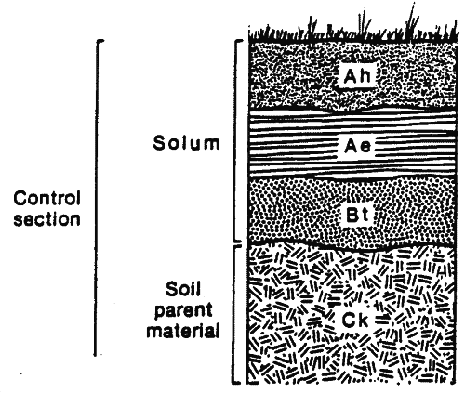
Importance of the top most layer.
- It contains most of the nutrients for plant growth.
Briefly explain the following terms.
- Soil texture. These are the different sizes of soil particles in an area.
- Soil structure. I the way soil particles are grouped/ arranged.
Activity
- What is soil profile?
- Name the soil layer which good for plant growth.
- Suggest any place where one can clearly soil profile.
- What is soil texture?
- Name any two organisms found in the soil.
LESSON 4 &5
SOIL EROSION
Is the washing away of top soil by its agents?
AGENTS OF SOIL EROSION
These are forces that carry away top soil from one place to another. These include:
- Running water
- Wind
- Animals
CAUSES OF SOIL EROSION
These are main activities that enable the agents to take away top soil.
How?
- They expose the soil to agents
These include
- Deforestation
- Overgrazing
- bush burning
- Monoculture (mono-cropping)
- Ploughing down slopes.
- Over cultivation.
TYPES OF SOIL EROSION
  - Sheet erosion: Top soil is washed away uniformly by running water
  - Gulley erosion (deep channels)
  - Rill erosion (shallow channels)
  - Splash erosion /raindrop erosion
  - Stream /river bank erosion
  - Wind erosion
Effects of soil erosion.
- Leads to soil exhaustion.
- It affects soil texture
PREVENTION AND CONTROL OF SOIL EROSION.
- Terracing: reduces the speed of running water
- Strip cropping: reduces the speed of running water
- Contour ploughing: is the ploughing across a slope.
It helps to reduces the speed of running water
- Afforestation: is planting of trees where they have ever existed. This also keeps the soil covered from direct rain drops.
- Re-afforestation: is the planting of trees where they have been ever existed. This also keeps the soil covered from direct rain drops.
- Cover cropping: planting cover crops between plants that take long to mature.
Cover crops
These are crops that are planted between plants that take long to mature
Qn: How does cover cropping prevent soil erosion?
Cover crops reduce the speed of running water
Qn: How does inter-cropping reduce soil erosion?
Reduces the speed of running water
- Bush fallowing: resting period of land to regain its fertility
Importance: enables the land to regain its fertility
- Mulching: is the covering of top soil with any plant material (dry plant materials)
Advantages of mulching.
- Controls soil erosion. How? By reducing the speed of running water.
- Maintains soil fertility. How? by reducing soil erosion and mulches rot to from humus.
- Keeps water in the soil. How? by controlling the rate evaporation of water from the soil.
- Increases on the crop yields.
- Reduces the rapid growth of the weeds.
Disadvantages of mulching
- Mulches keep pests.
- Dry mulches can be fire hazards.
- Some mulches can grow into weeds.
How soil loses its fertility
Through:
- Leaching. It is the sinking of plant nutrients deeper into the soil where plant roots can’t reach.
- Soil erosion
- Monoculture (mono-culture)
- Bush burning
How can we improve soil fertility?
- Mulching
- Crop rotation
- Bush fallowing
- Addition of fertilizers
- By terracing
- A forestation
Activity
1. What is soil erosion?
- Mention the three agents of soil erosion.
- give any three causes of soil erosion
- Name two types of soil erosion.
- Identify any one effect of soil erosion.
WEEK2
Lesson 1&2

FERTILISERS.
These are substances put in the soil to increase it’s fertility.
Types fertilizer
- Artificial fertilizers.
- Natural fertilizers.
ARTIFICIAL FERTILIZERS
Are fertilizers got from inorganic matter artificially.
Types of artificial fertilizers
- Straight fertilizers.
- Compound fertilizers.
Straight fertilizers.
These are fertilizers that supply one nutrient to the soil.
Examples: SSP (single supper phosphate), nitrogen, phosphorus, potassium.
Compound fertilizers.
These are fertilizers that supply more than one nutrient to the soil.
Examples: dramonium phosphate, NPK.
Advantages of using artificial fertilizers
- They have a high nutrient content needed by the plants.
- They are easy to handle, use and store.
- They help to make plants resistant to diseases as they grow.
- They provide the needed minerals with out fail.
- They supply a large quantity of mineral salts.
- They provide freedom of choice to farmers as they buy the type that they need.
- They improve crop yield.
- They supply the correct a mount of mineral salts to soil to meet the requirement of crops.
Disadvantages of using artificial fertilizers
- They are expensive to buy.
-They require skilled labour to apply it.
- They stay in the soil for a shorter period.
- They are poisonous to animals, people and birds.
- They pollute water sources when washed there.
- They destroy soil texture and structure.
- They make the soil acidic.
- They kill organisms in the soil.
Natural fertilizers (manure)
These are fertilizers made from decayed plant and animal materials[ humus)
Types of natural fertilizers (manure)
There are four types of manure
1. Compost manure
2. Green manure
3. Farm yard manure
4. Organic mulch.
ACTIVITY
  - What are fertilizers?
  - Name the two types of fertilizers.
  - Write in full SSP.
  - A part from straight fertilizer, mention another type of artificial fertilizer.

LESSON 3 &4
Compost manure
Is got from both plant and organic waste matter left to decay.
Things used to make compost manure.
- banana peeling.
- dry grass
- maize stalks
- leaves.
COMPOST HEAP.
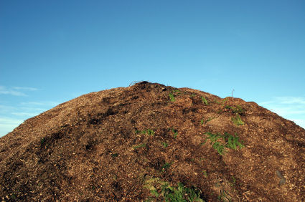

Importance of compost manure
- Adds humus to the soil (improves soil fertility)
- Controls leaching
- Improves soil structure
Advantages of compost manure
- It is cheap.
- Its nutrients last for a longer time
- It is not poisonous to people, animals and birds
- It does not require skilled labour to apply it.
- Provides many nutrients to the soil at the same time.
Nb: When making compost manure, water should be added to the compost heap to make the rotting faster.
Disadvantages of compost manure
- Produces bad smell
- It takes a lot of space
- Soil nutrients take long to be released into the soil
- It is not easy to tell which nutrients is present in the compost manure

Green manure
It is made from green crops especially legumes that are ploughed back into the soil at the flowering stage.
Why legumes? They can rot in a shorter time.

Advantages of green manure
- It lasts for several seasons in the soil.
- It rots and mixes easily into the soil.
- Its nutrients last for a longer time
- It is not poisonous to people, animals and birds
- It does not require skilled labour to apply it.
Disadvantages of green manure
- It is time wasting.
- It requires a lot of labour to plough it back into the soil.
- It is not easy to tell which nutrient is present in the green manure.
Farm yard manure
Is the manure got from animal wastes like dung and urine mixed with their bedding materials?
Advantages of farm yard manure
- It is cheap
- Its nutrients last for a longer time
- It is not poisonous to people, animals and birds
- It does not require skilled labour to apply it.
- Provides many nutrients to the soil at the same time

Disadvantages of farm yard manure
- It contains little amount of mineral salts.
- Produces bad smell
- It takes a lot of space
- Soil nutrients take long to be released into the soil
- It is not easy to tell which nutrient is present in the compost manure.
Effects of harmful materials on the soil
- Non degradable materials do not rot or decay
- They prevent or block air and water from entering the soil
- They lead to soil exhaustion.

These materials are called pollutants
Examples of soil pollutants.
- Polythene papers (buveera)
- Plastic materials
- Rubber materials (old shoes)
- Glass and broken bottles
- Metallic materials like nails, tins, etc
- Concrete from broken buildings.
Ways of properly handling wastes.
- Reusing plastic materials like jerry cans for other purposes like fetching water.
- Making new things from some wastes (recycle)
- Returning some wastes like bottles to the factories that make sodas.
- Rejecting/ refusing the use of non biodegradable materials like polythene bags.
- Reducing on the production of non biodegradable materials.
ACTIVITY
  - What is compost manure?
  - State two advantages of compost manure.
  - Suggest any two disadvantages of green manure.
  - What are soil pollutants?
  - Give two examples of soil pollutants.

LESSON 5&6
SOIL BARRIERS
These are things (materials) that prevent soil from being carried away by the agents of soil erosion.
Examples of soil barriers
- Grass ( cover crops)
- Trees /roots
- Rocks
- Concrete walls
- Contours
- Gabions. Etc
SOIL CONSERVATION
Is the maintaining (preserving) of soil fertility.
Methods of soil conservation
- Afforestation /re-afforestation
- Bush fallowing
- Terracing hilly areas
- Rotational grazing
- Contour ploughing
- Strip cropping
- Crop rotation
- Mulching
- Cover cropping
- Mixed farming
- Manuring /application of the fertilizers
- Agro-forestry.

Importance of soil conservation
- Retains soil fertility
- Retains soil moisture
- Prevents spread of diseases and pests.
ACTIVITY
- What are soil barriers?
- give any four examples of soil barriers
- What is mulching?
- State any two advantages and disadvantages of mulching.

WEEK 3
LESSON 1 & 2

FORMS OF ENERGY
Energy is the body’s ability to do work
Matter
Matter is anything that has mass and volume
OR
anything that has weight and occupies space
The meaning of each of the following
  - Mass: is a quantity of matter in an object.
  - Volume: Is the space occupied by an object.
c. Molecules: It is the smallest particles of matter.
d. Weight: is the gravitational force exerted on an object by the earth.
States of matter
There are three different states of matter

- Solids
- Liquids
- Gases

Solids
Examples of solids.
- Wood
- Rubber
- Glass
- Plastic
Characteristics of solids.
- Molecules are closely packed.
- Particles are held together very tightly.
- Molecules do not move from position but vibrate.
- Solids have shape, size and volume apart from irregular objects.
Diagram to show the arrangement of molecules.

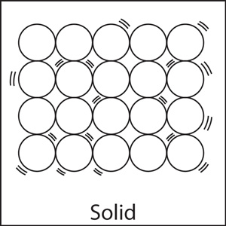
Liquids
Examples of liquids.
- Water
- Soda
- Oils
- Juice
Characteristics of liquids.
- Molecules are spaced.
- Molecules loosely held together.
- Liquids have a proper volume (capacity)
- Liquids have no definite shape (take up the shape of the container in which they are poured)
Diagram to show the arrangement of molecules.
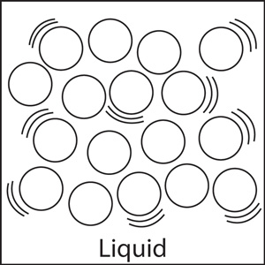
Gases
Examples of gases.
- Nitrogen
- Carbon dioxide
- Oxygen
- Rare gases
Characteristics of gases.
- Molecules are far apart
- Gases have no definite shape
- Gases have a particular volume.
- Molecules move freely.
Diagram to show the arrangement of molecules.

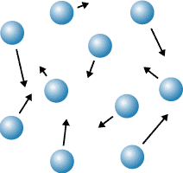
ACTIVITY
- what is energy?
- what is matter?
- name the three states of matter.
- in which state of matter are the following
  - water
  - metal
  - oxygen

LESSON3&4
ENERGY
Energy is ability to do work
Forms of energy.
- Heat energy
- Sound energy
- Light energy
- Sound energy
- Electric energy
- Magnetic energy
- Chemical energy
- Solar energy.
Types of energy
- Kinetic energy
- Potential energy
Potential energy
Is the energy that is stored by an object at rest.
Examples of potential energy
- A baby being asleep in a cot
- A car standing still at traffic lights
- A pupil sitting and listening to the teacher
- A stone / book ruler resting on a table /ground /cupboard etc

Kinetic energy
This is the energy possessed by a moving object or an object in motion. It is also referred to as the energy in motion
Examples of kinetic energy
- A girl running along the road
- An arrow flying through the air
- A stone thrown up in air
- A brick dropping from a wall
- A leaf falling to the ground from a tree
Think of a stone or a pendulum swinging in air
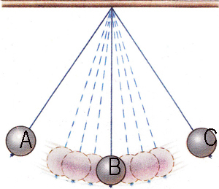
At A, the stone possess potential energy
At B, the stone possess kinetic energy
Activity
- Mention the two types of energy.
- Define the following types of energy
  - potential energy.
  - kinetic energy.
- List down any three forms of energy.

LESSON 5&6
HEAT ENERGY
Heat energy is a form of energy that increases temperature of an object
Standard units for measuring heat.
Heat Calories
Instruments used to measure heat.
Heat Calorimeter
sources of heat
These are objects that produce heat.
Types of sources of heat.
  - Natural sources of heat
  - Artificial sources of heat
Natural sources
Natural sources of heat provided by nature.
Examples.

- Sun (main natural source of heat)
- Food
- Stars
- Erupting volcanoes
Artificial sources.
These are sources of heat made by people.
Examples of artificial sources of heat.
- Lamps
- Bulbs
- Candles
Uses of heat to man
- used for ironing clothes
- Heat is used to run some machines e.g. steam engines. Diesel engines, rockets etc.
- used to dry harvested crops before storage.
- Heat evaporates the water in water bodies and plants during rain formation
- Heat enables us to cook our food
- Heat can act as a disinfectant.
Effects of heat on matter
Heat causes the following effects to matter.
- Melting.
- Expansion.
- Evaporation.
- Sublimation.
Diagram to show physical changes of state of matter.
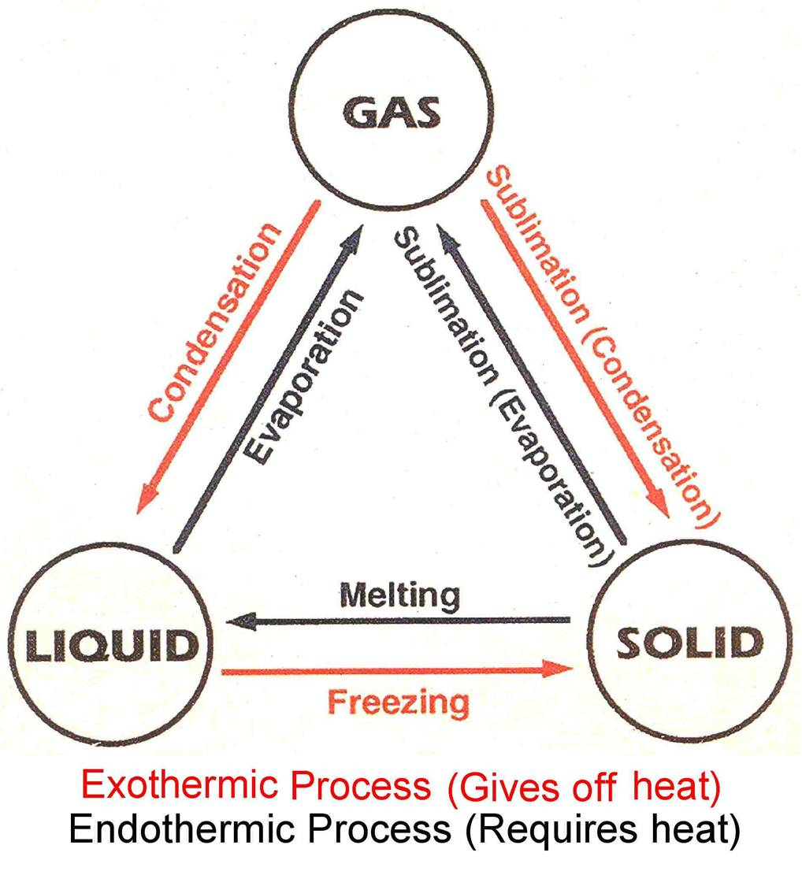
A - Melting physical change from solid to liquid
B - Evaporation physical change from liquid to gas.
C - Freezing physical change from liquid to solid.
D - Condensation – Physical change from gas to liquid
E - Sublimation physical change from solid to gas.
F - Sublimation physical change from gas to solid.

ACTIVITY
- What is heat energy?
- Name two the types of sources of heat in the environment.
- Give two examples of each of the following sources of heat
  - Natural source of heat.
  - Artificial source of heat.
- Identify any two effects of heat on a state of matter.
WEEK4
LESSON 1&2

EFFECTS OF HEAT ON EACH STATE OF MATTER.
SOLIDS.
- Metals expand.
Metallic ball ring experiment
a). Before heating the metallic ball goes through the ring.
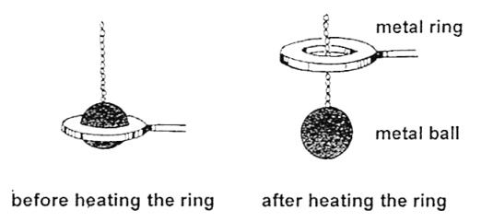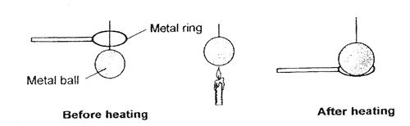

b). after heating the metallic ball does not pass through the ring

Reasons why metallic ball did not go through the ring after heating
The metallic ball had expanded
Conclusion
Metals expand when heated

LESSON 3&4
What do you think can happen to the metallic ball if dipped into cold water?
The hot metallic ball will contract and pass through the ring again.
Bimetallic strip.
Before heating and after heating
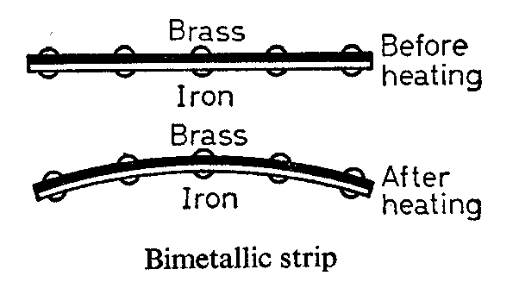
Observation
The iron strip heats up and expands faster than the copper strip hence bending to wards the copper.
Qn: 1. which of the two metals is the best conductor of heat?
IMPORTANCE OF A Bimetallic.
- Bimetallic strips are used in automatic switches of electric kettles, flat irons, fridges, freezers etc.
illustration of a railway line showing the gaps left during construction.
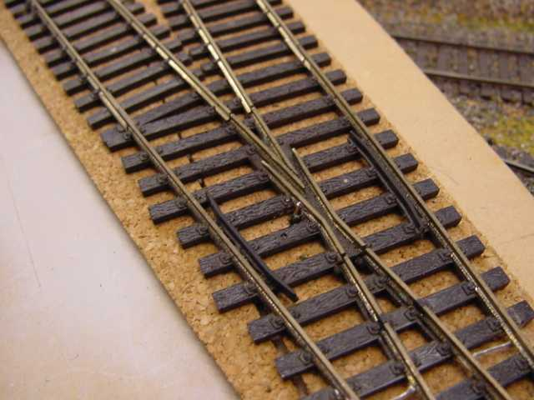
Qn: What happens if gaps were not left between rails during construction?
The rails would expand on hot days bend and cause railway accidents.
- Why are gaps left between railways during construction?
To leave room for expansion on a hot day.
Diagrams to show the effect of heat on electric / telephone wires
On a hot day.
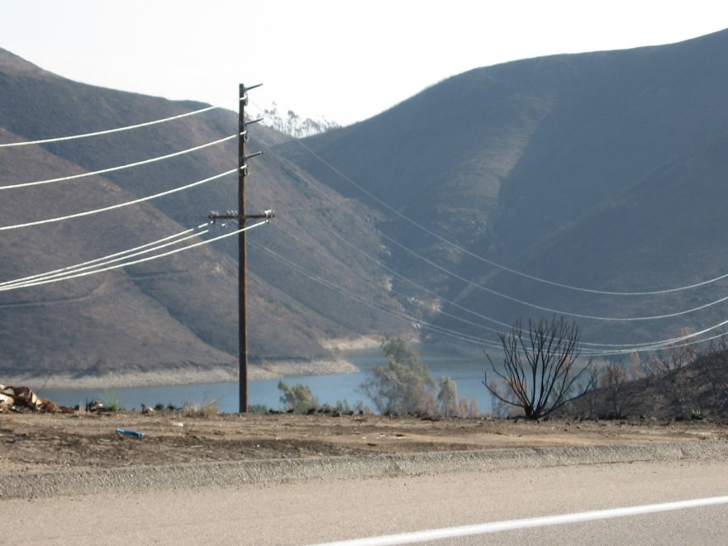
Electric / telephone wires expand become loose and starts sagging / slacking.
On a cold day wire contract and become shorter appearing relatively tight.

Qn; 1. Why are gaps left between electric / telephone wires during construction?
To allow room for expansion.
- What would happen to the wires when tied tightly fixed on the poles?
The wires would break due to contraction on cold days
Activity
- Why gaps left between the railway lines during construction?
- Why telephone wires are loosely fixed on the poles?
- what happens to electric wires on the following
  - Cold days.
  - Hot days.
LESSON 5&6

EFFECTS OF HEAT ON ICE.
What happens to ice when heated?
- Ice melts
- The volume decreases, the density increases and the mass remains the same.
EFFECTS OF HEAT ON GASES
What happens to gases when:-
a). Heated - Gases expand
b). Cooled - Gases contract
EXPERIMENT TO SHOW THAT GASES EXPAND WHEN HEATED.
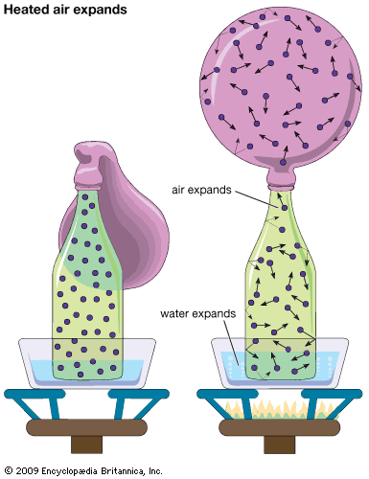
QN:1. Why does the balloon in diagram A expand?
Due to expansion of air inside the plastic bottle.
- What happens to the balloon when the bottle is removed from the hot water?
The balloon collapses due to contraction of the air inside the plastic bottle.

Effects of heat on liquids
- Liquids expand when heated.
- Liquids evaporate when heated.
- Liquids contract when cooled
Effects of freezing of liquids
- Liquids increase in volume
- Liquids reduce in density
- Mass of liquids remains the same.
Diagram to show that liquids expand when heated.
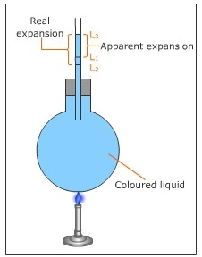
Qn: 1. why is space left while bottling drinks like soda?
To leave room for increase in volume when frozen.
- Why is carbon dioxide packed in bottled drinks like soda?
To preserve the soda.
A BOTTLE WITH THE SPACE LEFT

Space left to give room for
increase in volume on freezing.
Effects of heat on sublimates
NB: Sublimates are substances which can directly change from solid to gas.
Examples of sublimates
- Iodine granules (crystals)
- Ammonium chloride(salts)
- Solid carbon dioxide.

WEEK 5
LESSON 1&2
TEMPERATURE
Is the degree of hotness or coldness of an object.
Standard units for measuring temperature.
Temperature Degrees
Instrument used to measure temperature.
Temperature Thermometer
Thermometer
Thermometer is an instrument used to measure temperature.
The following thermometer measure the following:-
- Lowest temperature of the day Minimum thermometer
- Highest temperature of the day Maximum thermometer
- Room temperature or temperature of the air Wall thermometer
- Highest and lowest temperature of the day Six’s thermometer
- Human body temperature Clinical thermometer
Places where we find clinical thermometer in daily life
- In clinics
- In hospitals
- In dispensaries
Places or common sites on our bodies where a clinical thermometer can be placed while measuring the human body temperature
- Under the arm pits
- In the anus
- In the mouths / under the tongue
Diagram of clinical thermometer

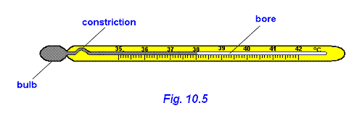

Importance of each part
Stem: Protects the inside parts of a thermometer
Kink: Prevents the back flow of mercury to the bulb before the actual temperature is taken.
Bore: The bore has a regular scale.
Bulb: The bulb store mercury.
Liquids commonly used in thermometers.
- Alcohol
- Mercury
ACTIVITY
- what is temperature?
- state the difference between heat and temperature.
- name the any one type of thermometer.
- which liquids are used in the thermometers
LESSON 3
SIX’S THERMOMETER ( MINIMUM AND MAXMUM THERMOMETER)
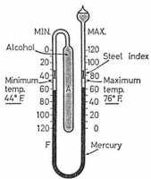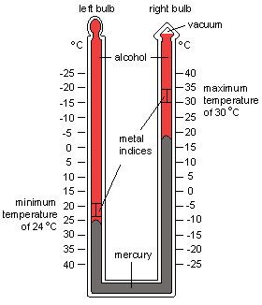
Reasons why mercury is used in a thermometer
- Mercury is a good conductor of heat
- Mercury does not stick on the walls of the bulb / bore.
- Mercury can easily be seen in the glass.
- Mercury has even and regular expansion.
Reasons why water is not used in a clinical thermometer
- Water is not easily seen
- Water is a bad conductor of heat
- Water needs a lot of heat to expand.
- Water’s does not expand uniformly.
Why do doctors shake a clinical thermometer before using it on other patients?
- To draw the mercury back to the bulb
Reason why a clinical thermometer is sterilized using surgical spirit
- Boiling it will make the stem expand and burst.
The normal human body temperature
- Celsius 37⁰c.
- 98.6/ 98.4degrees Fahrenheit.

LESSON 4
Changing from Celsius to Fahrenheit

  - 20⁰c
F = (c x 9) + 32⁰
5
F⁰ = (20 x 9) + 32
5
F⁰ = (4 x 9) +32
F⁰ = 36 + 32
⁰F = 68⁰
  - 25⁰c
F = (c x 9) + 32⁰
5
F⁰ = (25 x 9) + 32
5
F⁰ = (5 x 9) +32
F⁰ = 45 + 32
⁰F = 77⁰
  - 5⁰c
F = (c x 9) + 32⁰
5
F⁰ = (5 x 9) + 32
5
F⁰ = (1 x 9) +32
F⁰ = 9 + 32
⁰F = 41⁰

F = (c x 9) + 32⁰
5
F⁰ = (0 x 9) + 32
5
F⁰ = (0 x 9) +32
F⁰ = 0 + 32
⁰F = 32⁰

  - 80⁰c
F = (c x 9) + 32⁰
5
F⁰ = (80 x 9) + 32
5
F⁰ = (16 x 9) +32
F⁰ = 144 + 32
⁰F = 176^{0c}

  - 100⁰c
F = (c x 9) + 32⁰
5
F⁰ = (100 x 9) + 32
5
F⁰ = (20 x 9) +32
F⁰ = 180 + 32
⁰F = 212⁰

ACTIVITY
Change the following from degrees Celsius to degrees Fahrenheit
- 5^{oc}
- 10^{0c}
- 100^{0c}
- 0^{0c}
- 8^{0c}

^{LESSON 5}

Changing temperature from Fahrenheit to Celsius

Example 41⁰F to C⁰

C⁰ = (F – 32) x ⁵/₉
C⁰ = (41 – 32) x ⁵/₉
C⁰ = (41⁰ – 32) x ⁵/₉
C⁰ = 9 x ⁵/₉
C⁰ = 1 x 5
C⁰ = 5⁰

Change 68⁰F to C⁰
C⁰ = (F – 32) x ⁵/₉
C⁰ = (68⁰ – 32) x ⁵/₉
C⁰ = 36 x ⁵/₉
C⁰ = 4 x 5
C⁰ = 20⁰

Change 32⁰F to C⁰
C⁰ = (F – 32) x ⁵/₉
C⁰ = (32⁰ – 32) x ⁵/₉
C⁰ = 0 x ⁵/₉
C⁰ = 0 x 5
C⁰ = 0⁰
Change 59⁰F to C⁰
C⁰ = (F – 32) x ⁵/₉
C⁰ = (59⁰ – 32) x ⁵/₉
C⁰ = 27 x ⁵/₉
C⁰ = 3 x 5
C⁰ = 15⁰

Change 95⁰F to C⁰
C⁰ = (F – 32) x ⁵/₉
C⁰ = (95⁰ – 32) x ⁵/₉
C⁰ = 63 x ⁵/₉
C⁰ = 7 x 5
C⁰ = 35⁰

Change 77⁰F to C⁰
C⁰ = (F – 32) x ⁵/₉
C⁰ = (77⁰ – 32) x ⁵/₉
C⁰ = 45 x ⁵/₉
C⁰ = 5 x 5
C⁰ = 25⁰

ACTIVITY
Change from Fahrenheit to Celsius
- 68^{0c}
- 32^{0c}
- 41^{0c}
- 77^{0c}
WEEK 6
Lesson 1&2

HEAT TRANSFER
How heat travels through the states of matter
1. Solids by Conduction
2. Liquids by Convection
3. Gases by Convection
Vacuum by Radiation
Vacuum
A vacuum is a space without molecules.
Importance of molecules in heat transfer
- Molecule act as a medium of heat transfer.
Qn: In which state of matter does heat travel?
A) Fastest – gases
Why? The molecules in gaseous state move freely than in any other state of matter.
Slowest – Solids
Why? The molecules do not move freely.
An illustration of heat transfer in solids
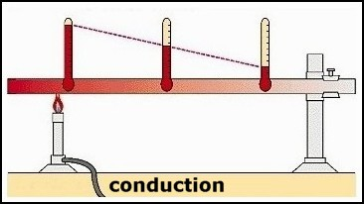
Qn: 1. how does heat move from point B to point A?
By conduction
- Which of the above wax will melt first?
Wax 1.
Reason: Wax 1 is nearest to the flame
- Which of the above wax will melt last?
Wax 4
Reason: wax 4 is furthest from the flame.
Importance of heat transfer by conduction
- Ironing our clothes using hot bodies like flat irons, iron boxes.
- Cooking food.
- Boiling water in a kettle.
- Welding or smelting metallic objects.
- Roasting meat using an iron rod.
Diagram to show convection of heat
- in gases.
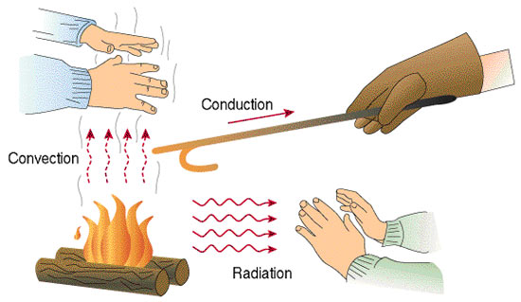

- liquids
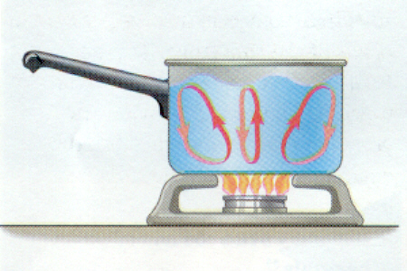
Importance of convection in our daily life
- helps smoke to move out of the kitchen through the chimney.
- Convection current helps in free circulation of fresh air in our houses.
- Convection currents help in formation of breezes.
- Taking of bad smell through the vent pipes of a VIP latrine.
Importance of each of the following on a house.
1. Ventilators: let out warm air
2. Windows: let in fresh air
3. Doors: let in fresh air
ACTIVITY
1. How does heat travel through the following
- Solids?
- Liquids?
- Gases?
- Vacuum?
- in which state of matter does heat travel
- fastest
- slowest
LESSON 3

SEA AND LAND BREEZE.
Sea breeze.
It is when cool gentle current from the sea moves to the land to replace the warm risen air. It occurs during day.
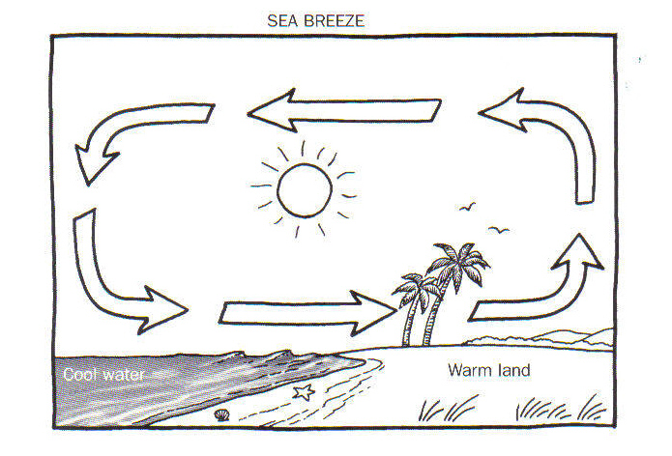
land breezes.
It is when cool gentle current from the land moves to the sea to replace the warm risen air. It occurs at night.

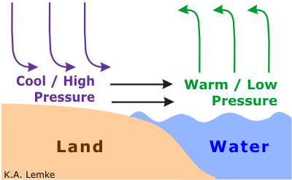
Nb: Sea breeze brings cool fresh air on land.
LESSON 4&5
RADIATION.
It is the process by which heat passes through a vacuum.
QN: How does a person standing in Namboole on sunny day receive heat from the sun?
By radiation.
Importance of heat transfer by radiation in the environment
- Radiation is used while roasting meat, fish or chicken in an oven.
- Warming our bodies using warmers or heaters.
- Dries harvested crops / wet clothes on wires.
Reflectors and absorbers or heat.
Reflectors: are shiny surface that reflect heat and light
Absorbers: are dull / black surface that absorb heat and light.

Examples of reflectors
- Mirrors
- Glasses
Absorbers
- Black clothes
- Black cars
Why are most houses, vehicles and fridges in most tropical countries like Uganda painted white? To reflect heat
If John washed a black and a white shirt and spread under sunshine;
  - Which shirt would dry first? The black shirt.
Reason: Black absorbs a lot of heat.
Last? The white shirt
Reason: The white shirt would reflect heat.
Conductors and insulators of heat
Good conductors: - are materials which allow heat to pass through them easily.
Examples of good conductors of heat

- Iron
- Mercury
- Aluminum
- Brass
- Zinc
- Copper
- Silver
- Lead

Insulators of heat
Insulators are the materials which don’t allow heat to pass through them easily.
OR
Insulators are bad (poor) conductors of heat
Examples of bad conductors of heat

- Distilled Water
- Rubber
- Plastic
- Paper
- Cotton wool
- Cloth
- Sponges.

ACTIVITY

  - How does heat from the sun reach people on earth?
  - State two importance of heat transfer by radiation in the environment.
  - What are insulators?
  - Give four examples of insulators.

Experiment to show that water is a poor conductor of heat
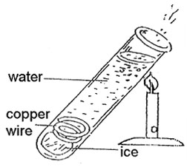
Observation
- Ice did not melt
- The water will boil at the area being heated while the ice cubes at the bottom will remain unmelted.
Use of conductors
- Used to make saucepans
- Used to make kettles
- Used to make bottoms of iron boxes
Insulators
- Paper is used to make cards
- Cloth keeps us warm
- Cork prevents heat loss in a vacuum flask.
- Why are handles of iron boxes, frying pans, flat irons made of wood, rubber / plastics?
To prevent the user from getting burnt.
LESSON 6
A VACUUM FLASK (THERMOMETER FLASK)
A vacuum flask keeps hot things hot and cold things cold.
A DIAGRAM OF A VACUUM FLASK
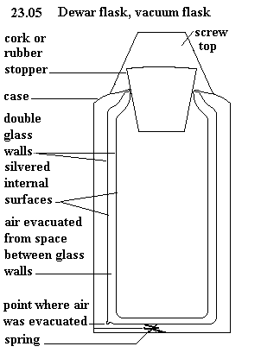
Uses of each part of a vacuum flask
Cork: Prevents heat loss or gain by conduction.
Silvered surfaces: prevents heat loss or gain by radiation (a good reflect of heat).
Vacuum: Prevents heat loss or gain by both conduction and convection.
Felt (cork base): Absorbs shocks to prevent the glass from breaking.
Felt are also poor conductors of heat.
Vacuum seal: Prevents matter form entering the vacuum.
ACTIVITY
  - Of what importance is the thermos flask at home?
  - Why is a vacuum seal important in thermos flask?
  - What is the use of the cork on the vacuum flask?
  - Why are the walls of a vacuum flask double silvered?
WEEK 7
LESSON 1, 2 & 3
OCCUPATIONS IN OUR COMMUNITY: CROP GROWING
CROP GROWING
ROOT CROPS
Root crops are crops that store their food in the swollen underground roots.
Examples of root crops
- Cassava
- Sweet potatoes
- Carrots
- Yams

STEM TUBERS
Are crops which store their food in swollen underground stems.
Examples of stem tubers
- Coco yams
- Irish potatoes

Which food values do we get from eating mostly root crops.
We get carbohydrates.
How are the following crops propagated?
Crop | Propagation
Cassava | By planting stem cuttings
Sweet potatoes | By planting vines / stem cuttings
Carrots | By planting carrot seeds
Yams | By planting the roots

DEMONSTRATION ON HOW TO GROW DIFFERENT CROPS.
CARING FOR ROOT CROPS
- By weeding the root crops (removing unwanted crops from the garden)
Importance of weeding
  - To reduce competition for sunlight, water and mineral salts between weeds and crops.
  - To prevent easy spread of pests and diseases from the weeds to crops
  - Improve the crop yields
- Pruning the crops (cutting off excess or poorly growing plants)
Importance of pruning
- To reduce over weight on the plants
- To prevent competition for sunlight carbon dioxide and oxygen
- Pruned materials can be used as mulches in the garden
Garden tools used for pruning crops
- Pruning saw
- Secateurs
- Thinning (removal of excess or poorly growing seedlings / crops in a nursery bed /garden)
Importance of thinning
- Creates space for the crops to grow well.
- Improves on the yields.
- There is less competition for nutrients from the soil
- Reduces hiding places for the crop pests
- The crops are easily sprayed with pesticides.
How is thinning done in the garden
- By uprooting unwanted crops manually
- Watering the crops (providing water for the plants to prevent withering wilting /drying up)
- The garden tool used for carrying water and watering the crops is called the watering can.
NB: We can also use an over head sprinkler or dig channels to allow the flow of water to the crops in the garden.
- Plant training /staking.
To grow in a desirable direction using strings and sticks
Examples of crops that can be trained /staked
- Tomatoes
- Passion fruits
- Vanilla
ACTIVITY
- What are root crops?
- give three examples of root crops.
- what are stem tubers?
- why is a sugar cane not grouped under stem tubers?
- how are the following crops propagated
  - cassava
  - sweet potatoes
  - bananas

LESSON 4&5
ROOT CROP PESTS AND DISEASES
Pests:
Pests are living organisms that destroy crops e.g. birds, worms, insects, rodents etc
Diseases:
Diseases are illness /sickness in living organisms i.e. plants and animals.

A TABLE SHOWING THE PESTS AND DISEASE THAT AFFECT VARIOUS ROOT CROPS
No | Root crops | Pests | Diseases
 | Cassava | Whitefly, monkeys, cassava scale, green cassava mites, caterpillars, wild pigs, rodents e.g. moles | Cassava mosaic, leaf spot, bacterial blight
 | Sweet potatoes | Eel worms, caterpillars, sweet potatoes, weevils, wild pigs, monkeys, rodents | Potatoes blight, bacterial wilt sweet potato mosaics
 | Carrots | Aphids, moles, eel worms, cut worms, root knot, nematodes | Bacterial wilt, leaf spot, a leaf rust
 | Yams | Termites, Locusts, Mole, Yam beetles | Leaf spot and leaf rust (fungi)

CHARACTERISTICS OF ROOT CROP PESTS
- Pests which damage the shoot system (leaves and stem /braches) have strong mouth
parts to cut and chew the leaves.
- Pests which destroy the tubers have sharp claws which help them to dig the soil
- They have sharp incisors which bite or cut the roots /tubers.
- Other pests that damage root crops have fingers which they use to uproot the root a crop e.g. apes and monkeys.
Examples
- Locusts
- Caterpillars
- Army worms
- Sweet potatoes weevils
- Variegated grasshoppers

HOW TO CONTROL CROP PESTS
- By spraying the crops with pesticides.
Dangers of pests to crop farmers
- Pests damage farmer’s crops
- Reduce on the crop yields
- Cause decaying root crops
- Wastes money to control
Uses of pests to farmers
- Some pests are a source of food to man e.g. grasshoppers and locusts.
- Some are eaten by farmer’s poultry e.g. caterpillars
ACTIVITY
- What is thinning?
- Of what importance is thinning to a crop farmer?
- Identify any one garden tool for pruning crops.
- What are pests?
- Give one way of controlling pests.
LESSON 6
FOUR MAJOR CONTROL METHODS OF PESTS
- Mechanical control method
E.g.
  - physical guarding (Fencing the garden)
  - Silting traps /scares
  - Staying scary crows
The above methods can control pests like wild pigs, moles, birds, rodents etc
- Biological pest control
This is where a predator is used to control the pests e.g. you can tame a cat to kill rats.

- Cultural methods
- By practicing crop rotation
- The available pests of a particular crop
- Early planting and harvesting
- Practicing resident species /varieties
- Through proper control of weeds
- By planting disease free cuttings /vines
- Chemical control method; is a method where a farmer sprays pesticides /insecticides to kill the pests

HARVESTING AND STORAGE OF ROOT CROPS
Harvesting
Harvesting is the removal of mature and ready crops from the garden.
Storage
Storage is the keeping of harvested crops safely for future use
Sweet potatoes
- Mature within the first six months after planting.
- However, first growing varieties mature within three months
- Potato tubers do not mature at the same time, but keep growing as you harvest the ready /mature tubers.
- Ready sweet potatoes make cracks in the soil
- Farmers spot the cracks and harvest the ready tubers using sharp sticks or sharp pointed metal rods.
- Sweet potatoes tubes can as well be harvested at once using hoes mostly for scale.
- Harvested tubers can be peeled, cooked and eaten immediately
- The surplus can be sold in market or sliced into tiny pieces, dried and stored in cool /dry places.

Cassava
- Some varieties take 6 months to mature others take up to 1 year.
- During harvesting the whole plant is dug out using a hoe and tubers removed
- While preparing cassava for eating, you peel using a knife, wash, cook and eat.
- Surplus cassava can be sold off in markets or slices and dried before storage or dried slices can be pounded to make cassava bread or pan cakes, local beer (kwete), local glue.
Methods of storing root crops
- Temporary storage e.g. burying the tubes under wet soil
- Long time storage (after drying the slices) e.g. storing in granaries /sacks /slices (modern stores) silos
ACTIVITY
- What is harvesting?
- Why is dry season important to crop farmers?
- Suggest one biological method of controlling crop pests.
- Mention one method of harvesting crops.
- Name the modern method of storing harvested crops.
WEEK 8
LESSON 1&2

KEEPING AND USING FARM RECORD
Farm records
These are details or information concerning all activities that take place on a farm.

Example of farm records used on root crops
- Farm inventory e.g. farm equipment size of lands.
- Cash record e.g. money spend or received when carrying out the project
- Non-cash records – unpaid for labour may be family members
- Records of production e.g. number of acres planted /map of the farm

Importance of keeping farm records
- To know the progress of the farm
- Proper records can be used to get loans in the bank
- To plan for the farm for future use
- To know whether the farmer is making profits or losses.
SPECIMEN OF FARM RECORDS SHEET
Date | Crop planted | Date of weed control | Date of manuring | Date of harvest | Date of sale
2/2/2005 | cassava | 3/3/2005 | 3/4/2005 | 7/7/2005 | 13/5/2005

SCIENCE CLUBS /SOCIETIES IN THE SCHOOL
The science club
Involve learners in science related activities
Examples of Science related societies.
- Wildlife clubs
- Red cross clubs
- Young farmers clubs
- Science contest
- Science exhibition
- Science quizzes
- Science projects
- Science paper presentation etc
Importance of science activities to learners
- Develop a positive attitude in learners towards science.
- Expose learners to the kind of work that can lead to their career
- Shape learners for their future career in the science field i.e. doctors, engineers, surgeons, dentists, electricians, and agriculturalist.

Wildlife club
Enables learners to learn more about uncultivated plants and wild animals that exist in the natural environment.
Roles of the wild life club
- Protecting the environment.
- Conserving the environment.
- Teaching or sensitizing others to protect or conserve the environment.
Activities done by the wildlife clubs in school
- Maintaining a free nursery in the school
- Tree labeling
- Establishing wood / tree projects
- Monitoring wildlife abusers e.g. poachers
- Bird watching
- Preventing water, air and soil pollution
- Setting up a botanical garden
- Construction of an aquarium
Aims of the science oriented clubs in school
- To promote /boost children’s interests in the science subject
- To enable children to know how scientists work.
- To equip learners with knowledge and skills for their future career.
- To promote learning of science in the school.
The young farmers clubs
The young farmers clubs include young boys and girls in and out of school who are interested in farming.
Roles of the young farmers clubs
- To keep animals and grow crops.
- To teach other farmers better farming methods.

Qn: When are the activities of young farmer’s clubs done?
- After school time
Qn: Under which department / ministry in Uganda are the young farmers clubs
- Department of agriculture
Role of the department of agriculture in young farmers clubs
- To unite all the young farmers’ clubs in the country.
- To set up competitions in school where prizes are given to winners.
- Train and send technical people to teach and answer questions of the young farmers.
- To teach young farmers better farming methods.
- To start money making and savings projects for self support.

Topical questions
  - How can root crops be cared by crop farmers
  - Give any two examples of stem tubers
  - State the importance of farm records on a crop farm
  - Identify the main role of the wildlife club in a school like greenhill
  - Which is the best season for crop growing
  - How are the following crops propagated
Sweet potatoes
Cassava
Carrots
  - Which food value is mostly obtained from root crops
  - Give the difference between a pest and a parasite.

LESSON 3&4
BACTERIA AND FUNGI
Bacteria means a microscopic single celled organism that are present almost every where.
Places where bacteria are mostly found
- Animal bodies
- Contaminated water
- Soil
- Nodules of legumes
- Latrines
- Rubbish pits
- Air
- Contaminated food
How do bacteria reproduce
- By cell division (binary fission)
- By spore formation
Diagram
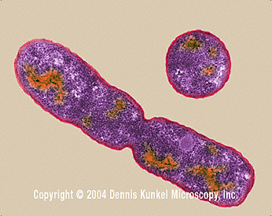
Types of bacteria
- Rod shaped bacteria (bacilli)
- Spherical shaped bacteria(cocci)
- Spiral shaped bacteria

1. Rod shaped bacteria (bacilli)
e.g bacillus anthraces for anthrax, salmonella typhi for typhoid
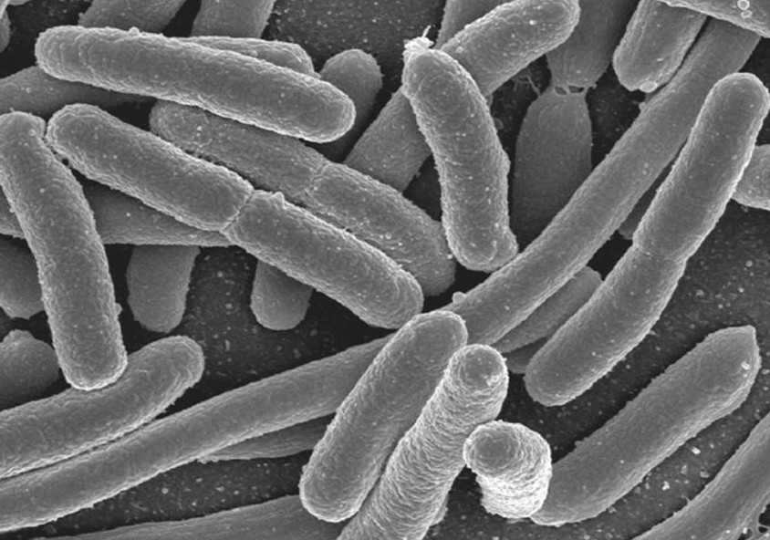

2. Spherical shaped bacteria(cocci) e.g staphylococci for boils, streptococcus for sore throat, diplococci
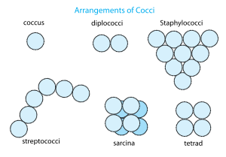

3. spirochaete for syphilis
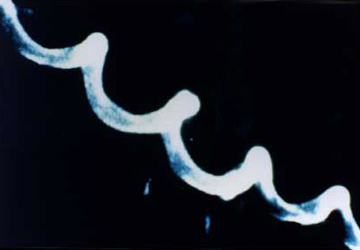

- Coma shaped bacteria (vibrios)
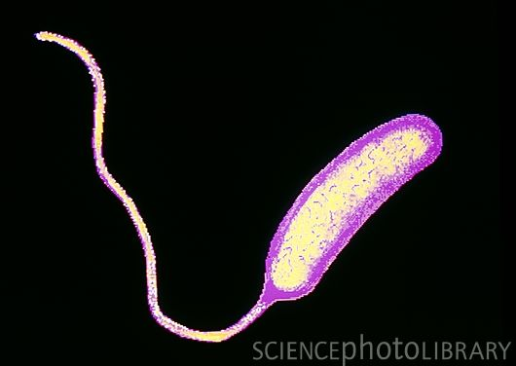
ACTIVITY
- What are bacteria?
- How do bacteria reproduce?
- Identify one place where bacteria can be found.
- In which way is reproduction in bacteria similar to that in fungi?
- which type of bacteria course the following disease
- Gonorrhea?
- Syphilis?
- Cholera?
LESSON 5
Importance of useful bacteria
- Nitrogen fixing bacteria fix nitrogen back into the soil to improve soil fertility
- Bacteria break or digest fibre food/ roughage / cellulose in the caeca of birds
- Bacteria help in decomposition / rotting of dead plants and animals
- Bacteria help too reduce on the amount of faeces in pit latrines as well as sewage tanks
- Bacteria help in fermentation of beer, ghee, yoghurt and cheese.
- Bacteria help in making humus (manure) in compost pits)
- Bacteria help to reduce on the amount of garbage as they rot.

Dangers of harmful bacteria
1. Harmful bacteria cause diseases to both animals and plants.
2. Bacteria cause poor yields to crops
- Bacteria cause food poisoning
- contaminates food and makes it poisonous to human health
- Some cause diseases.
How to control dangers caused by harmful bacteria
- by preserving food(keeping food free from bacteria)
- by observing proper food hygiene i.e. ensuring that food is kept in a clean environment and clean containers
- by using antiseptics(drugs that kill germs on cuts and wounds)e.g. detol, saloon, hydrogen peroxide tincture of iodine etc
- by sing disinfectants to kill bacteria in places like bacteria and reduce the bad smell e.g. harpic, jeyz , etc
- by using antibiotic (drugs used to kill bacteria in our bodies) inform of injections, tablets, capsules, syrups e.g. penicillin from penicillium) that was discovered by Alexander Fleming, etc
- through sterilization of medical instruments e/g springs
- through pasteurization (involves) heating the food stuffs to a high temperature and sealing it before suddenly cooling it)
it was discovered by Dr. Louis Pasteur to preserve milk. He also discovered the vaccines against anthrax and rabies.

LESSON 6

FUNGI
Fungi are simple organisms that obtain their food from decaying plants and animal matter.
Fungi are saprophytes because they feed saprophytic ally (obtain soluble food from dead organic matter)
Examples of fungi
- Mushrooms
- Moulds
- Yeasts
- Puffball
- Toad stools (poisonous fungi)

Characteristics of fungi
- Fungi exist in both as single celled (unicellular) or multicellular organisms.
- Fungi lack chlorophyll (they can make their own food)
- Fungi feed saprophytic ally or parasitically
- They have nuclei in their cells

Importance of fungi
- Some fungi like yeast are used to bake bread and cakes
- Some fungi like mushrooms are a source of food to man
- Some fungi like moulds (penicillium rotatum) are used to make medicine penicillium
- Yeast is used to brew local beer or ferment fruit juices to make wine
- Fungi help in decomposition of rubbish in rubbish pits to make humus
- Yeast is used to flavors cheese
- Yeast is a source of vitamin B that prevents beriberi
Mushrooms
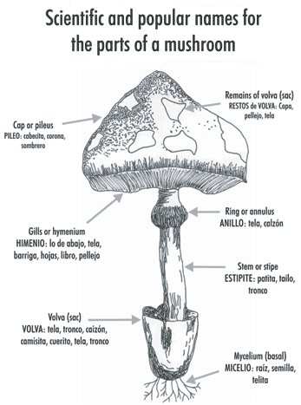
IMPORTANCE OF MUSHROOMS.
- They are eaten as food.
- Some mushrooms are sold to get money.
- Mushrooms are used for study purpose.
Activity
- What are fungi?
- How do fungi reproduce?
- Give examples of fungi.
- Draw a mushroom and name the cap, gills and stipe.

WEEK 9
LESSON 1 & 2

How do fungi reproduce?
Most fungi reproduce by means of spores unlike Yeast which reproduces by budding
Diagram
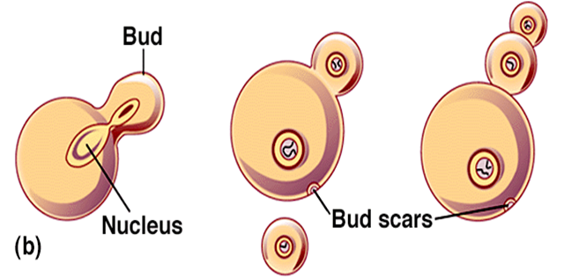

Danger of harmful fungi
- Harmful fungi cause food poisoning
- Harmful fungi cause a number of diseases to both plants and animals

Examples of fungal diseases in animals
- Ring worms (cause round patches on the skin)
- Athletes foot (attacks the skin between the hoes)
- Thrush caused by candida
- Finger nail deformation

Examples of fungal diseases in plants
- Panama e.g. banana
- Cigarand rot
- Blast wilt
- Coffee berry disease (rust) coffee plant
- Root rot in tea plants.
How to control the dangers caused by harmful fungi
- Boiling milk and water before drinking.
- Reheating and warming cold food before eating it.
- Salting the food.
- Pickling – putting vinegar in edible vegetables and other foods.
- Avoid eating uncovered food.
- Spray plants with fungicides.
- Get early treatment for any fungal infection /disease.
- Sterilize all surgical instruments to kill all the germs.
- Irradiation in canned foods.
- Avoid eating or catching poisonous fungi.
- Proper management of house refuse and rubbish
- Proper use of the latrine.
- Avoid sharing towels, socks, under wears etc.
- Use medicated soap to bathe e.g. detol , protex, etc.
- Use disinfectants in cleaning toilets e.g. jeyz.
Similarities between bacteria and fungi
- Both feed saprophytic ally
- Both cause fermentation
- Both can cause rotting /decomposition
- Some of them cause diseases while others are useful to man
- Some are single celled while others are multicellular
Differences between bacteria and fungi
- Bacteria reproduce by means of cell division (binary fission) while fungi reproduce by means of budding and spores.
- All bacteria are very tiny microscope while some fungi like mushrooms are big
- Bacteria reproduce much faster than fungi
- Some bacteria make their own food by combing some simple chemical substance while fungi cannot make their own food

Topical questions
1. How are bacteria different from fungi?

---------------------------------------------------------------------------------------------------
2. Where are bacteria found in our environment?

---------------------------------------------------------------------------------------------------
3. Name any one poisonous fungi

---------------------------------------------------------------------------------------------------
4. Give the three types of bacteria

---------------------------------------------------------------------------------------------------
5. Which bacteria do the following?
a) Add nitrogen back into the soil

---------------------------------------------------------------------------------------------------
b) Make food go bad

---------------------------------------------------------------------------------------------------
c) Cause typhoid

---------------------------------------------------------------------------------------------------
d) Cause cholera

---------------------------------------------------------------------------------------------------
6 Identify any two immunisable disease caused by bacteria

---------------------------------------------------------------------------------------------------
7 How do the following reproduce?
a) Yeast
---------------------------------------------------------------------------------------------------
b) Bacteria
---------------------------------------------------------------------------------------------------
8 Give the importance of fungi to people

---------------------------------------------------------------------------------------------------
9 How are bacteria useful to people?

---------------------------------------------------------------------------------------------------
10 In the space below, draw a mushroom and label all the parts

---------------------------------------------------------------------------------------------------

LESSON 3 & 4

Mixture
A mixture is when two or more different substance are mixed together e.g. when we mix sand and cement we get concrete blocks
Dissolving substance/ solutes.
These are substances that dissolve when put in water/ any liquid after stirring.
So, solutes are soluble in water or the liquid
Examples of solutes.
- Sugar
- Salt
- milk powder
Insoluble substances.
Substances which don’t completely dissolve in any liquid or water.
e.g. sand, maize flour, stones etc
A suspension: is a substance where the solute does not completely dissolve in
the solvent.
Solvent.
Is a substance in which a solute dissolves.
Examples.
- water
- petrol
- methylated spirit
Nb: Water is universal solvent because it dissolves almost all solutes.
solution.
Is a uniform mixture of a solute and solvent.
saturated solution is a solution which dissolves more solutes after heating it.
Super saturated solution is a solution which cannot dissolve any more solute even offer heating it.

SEPARATION OF MIXTURES.
  - Filtration.
It is a process of separating solid particles from a liquid using a filter.
The solid particles that remain in the filter are called residues.
The liquid that passes through is called a filtrate.
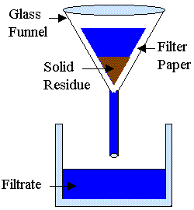
How filtration method can be applied in our homes.
  - When separating passion, orange, etc fruit juice from the seeds.
  - When separating clear water from muddy water.
LESSON 5

2. Decantation.
It is when solids particles are allowed to settle at the bottom of a liquid then a liquid is carefully poured off to separate it from the solid particles.

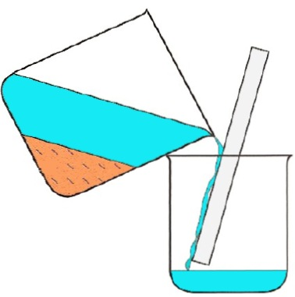
The solid particles that remain in the one container is called a residue.
The liquid that is collected in another container is called a decantee.

How decantation method can be applied in our homes.
1. When separating passion, orange, etc fruit juice from the seeds.
  - When separating clear water from muddy water.
Qn: Why is it important for one to first shake a syrup before taking it?
For the medicine to mix with the liquid that has settled at the top.
LESSON 6
- Distillation.
It is the making of dirty water pure by evaporation and condensation.
Nb: Distilled water is not good for drinking because it lacks mineral salts.
The substance that remains in the container is called a residue.
The substance that is collected in the second container is called a distillate.
Distilled water is used to mix drugs in hospitals.
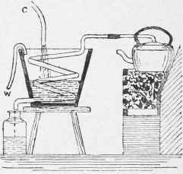

Experiment on how to separate mixtures.

SEPARATION OF MIXTURES OF SOLIDS.
- Floatation.
It is a method of separation of mixtures where one sinks and the other floats.
- Using magnets to separate metallic objects from non metallic objects.
- Hand picking / sorting.

TERM THREE
CHANGES IN THE ENVIRONMENT
Environment: Environment means the surrounding of people.
Types of changes in our environment

- Physical changes
- Chemical changes
- Biological changes
- Atmospheric change

Biological changes: Are changes that take place in our body cells and affect the growth.
Examples of biological changes

Growth
Germination
Fertilization
Moulting
Flowering
Fruiting etc.

Characteristics of biological changes
- New organisms come into being e.g. young ones of animals, seedlings in plants.
- Young ones grow old.
- Increase in number of off springs
- Increase in harvest / yields.
Chemical changes
These are changes where a new substance is formed or
Chemical changes are changes which are irreversible
Characteristics of chemical changes
- A new substance if formed
- Are irreversible
- Heat or light is sometimes given off or absorbed
- The amount size of weight of the object changes.
Examples of chemical changes

- Burning
- Rusting
- Respiration
- Digestion
- Photosynthesis

Advantages of chemical changes
- Chemical changes like burning produce heat
- The heat produced is used to cook
- Production of energy during respiration
Disadvantages of chemical changes
- Rusting results into wearing out of iron materials, steel equipment
- Bolts become difficult to open unscrew.
- Keys fail to fit in the padlock after rusting
- Water and air become poisonous to human life.
- Pollutes the environment ie smoke.
Physical changes
Physical changes are changes where no new substances are formed.
OR
Physical changes are changes which are reversible.
Examples of physical changes

- Evaporation
- Condensation
- Freezing / solidification
- Melting
- Sublimation

Characteristics of physical changes
No new substance is formed
Are reversible
No heat or light is given off or absorbed
Advantages of physical changes
- Formation of rainfall
- Formation of ice cubes
- Forms water for drinking
Disadvantages of physical changes
- Causes soil erosion
- Forms gulleys
- Causes loss of soil fertility
Weather changes in the atmosphere

- Humidity
- Cloudy
- Rainy
- Sunny

Natural and people made changes
Natural changes: Means changes that occur by themselves e.g. wing movement, changes in climate e.g. dry season, wet season, rainfall formation
Man made Changes: Are changes that are caused by man.
Examples of man made changes

- Tree planting
- Deforestation (Tree cutting)
- Bush burning
- Construction of houses
- Road construction

Effects of changes in the environment to plants and people
- Mulching
Importance
  - Kills weeds
  - Preserves moisture in the soil
  - Improves soil fertility
- Time planting
Importance
- Controls soil erosion
- Helps in fain formation
- Provision of weed fuel
- Tree cutting
Effect:
- Destroys the environment
- Exposes soil to agents of soil erosion
- Reduces the amount of rainfall
- Bush burning
Effects
- Soil erosion
- Loss of soil fertility
- Building houses
Effects
- Houses protect people and their property from bad weather e.g. rain fall, coldness, sunshine.
- From thieves
- Wild animals

- Road construction
Effects
  - Road construction helps to improve transport
  - Destruction of vegetation
  - Poor roads cause / lead to accidents and damage of vehicles
- Pollution
Quality of environment
- Air pollution
- Land pollution
- Water pollution

KEEPING GOATS, SHEEP AND PIGS
Common terms used
1. A nanny goat: Is a mature female goat.
2. A Billy goat: Is a mature male goat.
3. A kid: Is any young goat.
4. Kidding: Is the act of giving birth in goats.
5. Browsing: Feeding on the soft parts of a plant.
6. Tethering: Is the system of grazing where an animal is tied on a peg (stake) on a rope.
7. Heat period: Is a period when a nanny goat is ready to be mated.
8. Weaning: Is the introduction of kids to other foods on addition to breast milk.

Why farmers keep goats and sheep
1. For milk production.
2. For meat production.
3. For source of income (for sale and get money)
4. For giving dowry / bride price.

Other uses of goats to man.
1. The skins from goats are used to make leather products like shoes, straps for watches, belts, drum tops, bags and costumes for dancing among others.
2. The dropping from goats are used as farmyard manure.
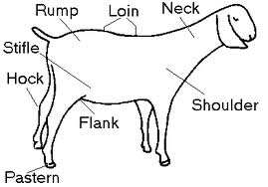
EXTERNAL PARTS OF A GOAT

BREEDS OF GOATS
The two main groups of breeds of goats are:-
1) Local breeds (indigenous)
2. Exotic breeds (foreign)

Examples of local breeds of goats
i) Mubende goats
ii) Golla goats
iii) Turkana
iv) Sambaru goats
v) Anglo– Nubian
vi) The Somali goat East African small goats

Advantages of local breeds
i. Local breeds are resistant to tropical diseases.
ii. Local breeds can with stand harsh weather conditions.
iii. Local breeds are easy and easy to manage as they feed by browsing.

Disadvantages
i) Take long to mature
ii) Produce hard meat.
iii) They produce less products.

Define the scientific term browsing.
Browsing is the feeding on the soft parts of a plant by goats.
How often do goats breed in a year?
Goats breed once in a year.
EXOTIC BREEDS OF GOATS
Exotic breeds are kind of breeds imported into Uganda from other countries.

Examples of exotic breed of goats
i. Toggenburg
ii. Angora goats
iii. Saanen goats
iv. Boar goats

Meat breeds
i. Boar goat
ii. Galla goats
iii. Mubende
iv. The Somali goats.

Milk producing breeds
i. Saanen goats
ii. Toggenburg

Wool breeds
Angora goats (mohair)

Cross breeds
Somali goats

Advantages of keeping Exotic breeds of goats.
i. They grow very fast.
ii. They fetch a lot of money when sold.
iii. Produce tender meat.
iv) They produce a lot of meat and milk.
Disadvantages of keeping exotic breeds.
i. They are expensive to keep.
ii. They are not resistant to worms and diseases.
iii. They cannot withstand harsh weather.
iv. They need special feeds to produce better products.

BREEDING IN GOATS
i) A female goat is mated for the first time at the age of 14 – 18 months.

Gestation period of a goat.
The gestation period of a nanny goat is 5 months (150 days)

Some key terms as used in goat keeping
- kidding: The act of giving birth to kids.
- Gestation period: The period between fertilization and birth in mammals (animals).
- Lactation: Is the milking period in animals.

HEAT PERIOD IN GOATS
Heat period is the time when the nanny goat is ready to be mated by a Billy goat.
Signs of a nanny goat on heat
i. Becomes restless (unsettled)
ii. The vulva swells and becomes reddish.
iii. Whitish discharge from the vulva.
iv. Mounting other goats.
v. Standing still when mounted.
vi. Loss of appetite.

CARING FOR A PREGNANT GOAT
- A pregnant goat needs special care.
- Concentrates should be given one month before kidding.
- These feeds have a high carbohydrates and protein content.
- Mineral licks should be given.
- Pregnant goats should be separated from others and kept in a clean place.
- Weaning should be done at least 3 - 4 months after kidding.

Signs of a good milk breed
i. It has a large under and teats.
ii. Have large milk veins which appear below the belly.
iii. Have strong and well placed hind legs.
iv. Have strong back muscles.

ROUTINE JOBS IN GOAT MANAGEMENT
What are routine jobs?
Routine jobs are any good management practices carried out on any livestock farm.

Examples of routine jobs on a livestock farm.
i. Castration v. Drenching ix. Culling
ii. Disbudding vi. Spraying or dusting
iii. Dipping vii. Dosing
iv. Hoof trimming viii. Feeding

Castration
Castration is the removal of testes from a young male animal.

Methods of castration
i. Closed castration (using a burdizzo castrator or elastrator)
ii. Open castration. (scaped operation) – The knife can be used to cut the scrotum / scalped used by veterinarians.

Advantages of castration.
i. A castrated animal grows fatter and faster.
ii. Castration prevents in-breeding.
iii. Prevents the spread of STD (Sexually Transmitted Diseases).
iv. Helps to make the male animal calm (docile) and easy to handle (tame).
v. Castration helps to improve on the quality of meat.

Disadvantages of castration
i. Animals feel a lot of pain.
ii. The wound may become septic.
iii. The cut opens way to germs.
iv. It is expensive to buy a burdizzo or hire a qualified person to carryout castration.

Dehorning
Dehorning is the removal of horn buds to prevent the growth of horns.

Disadvantages of disbudding
i. Creates space on the farm.
ii. Helps in identification of ones animals.
iii. Prevents livestock animals from injuring others.
a) Hoof trimming: Is the cutting off of over grown hooves. It is normally done in sheep. A trimming knife or hoof trimming shears are used.
Importance: To reduce the chances of infections and injuries.
b) Dipping: Is the bathing of livestock in acaricides in a dip tank to kill ecto-parasites.
Importance: Helps to kill ecto-parasites e.g ticks.
c) Drenching: Is the giving of liquid medicine to the livestock through the mouth.
Drenching is done using a drenching gun or bottle.
d) Spraying: Is when a fumigator or knap sack sprayer is used to spray insecticides / pesticides to kill ecto parasites.
Importance: Prevents tick borne diseases like Red water, Heart water, etc.
e) Dusting: Is the application of powdered medicine on the body of an animal to kill ecto-parasites.
f) Dosing: Is the giving of solid medicine e.g Tablets using a dosing gun to kill endo-parasites like worms.
g) Feeding: Is done using supplements, mineral licks, concentrates and fodder.

GRAZING ANIMALS
These are many methods of grazing animal, namely:
- Rotational grazing
- Tethering
- Strip grazing
- Paddock grazing
- Free range grazing (herding)
i) Tethering: Is when an animals is tied with a rope onto a peg to graze around.
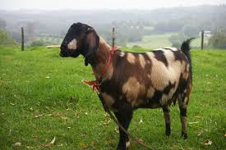
Diagram of a tethering goat

Advantages of tethering
i) Ensure efficient use of pasture.
ii) Enables the growth of pasture in other areas.
iii) Controls soil erosion as over grazing is avoided.
iv) Controls spread of parasites and diseases.
v) Allows pasture conservation.

Disadvantages tethering grazing
i) Animals cannot get enough food (pasture).
ii) It is tiresome to keep on changing the animals.
iii) The rope can cause injuries to the animal.

2. Free range grazing (herding)
Is where the animals are left to roam and gaze freely.
Advantages:
i) Animals can easily get lost and stolen by thieves.
ii) Animals can stray and spoil crops.
iii) Animal diseases are easily spread.

3. Zero grazing (stall feeding)
Zero grazing system needs more attention than tethering.
This method is suitable for small scale farmers and in areas where most land is used for crop growing.

The shelter for goats
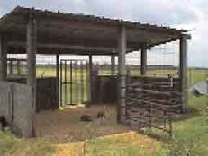

SHEEP REARING
TERMS USED IN SHEEP REARING
a) Ram: a mature male sheep.
b) Ewe: a mature female sheep.
c) Lamb: a young one of a sheep.
d) Lambing: Is the act of giving birth in sheep.
e) Mutton: Is the meat of sheep.
f) Shearing: Is the removal of over grown wool from the sheep.
g) Docking: Cutting short of lamb’s tail.
h) Gestation period: Period of pregnancy in animals OR
Gestation period is a period between conception and birth.

Importance of docking sheep
To allow easy mating and prevent injection.
Why do farmers keep (rear) sheep
i) For mutton production.
ii) For wool (mohair) production mostly in cold climate areas.
iii) For sale (income generation)
iv) For cultural purposes e.g sacrifice, rituals, pay dowry or bride wealth.

3. A part from wool and mutton, give any other products got from sheep.
i) The skin used to make feather, product like belts, bags, shoes, e.t.c
ii) Horns and hooves used for making office glue, buttons or decorations.

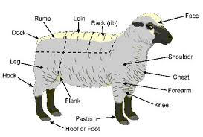
External parts of a sheep

GROUPS OF SHEEP KEPT IN UGANDA
1. LOCAL BREEDS (indigenous)
i) East African breed / Blacks headed Persian.
ii) The Somali
iii) The masai

2. EXOTIC BREEDS OF SHEEPS
i) Hampshire down sheep.
ii) Dorper sheep.
iii) Romney marsh
iv) Corriedale
v) Merino
vi) Ramboulet

Mutton breeds of sheep.
All local breeds are reared for mutton e.g
i) Black headed Persian.
ii) The Somali
iii) The masai e.t.c

Exotic meat breeds kept for mutton
i) Hampshire
ii) Dorper
iii) Chirot
iv) Sufflock
v) Dorset

Dual purpose sheep
Dual purpose sheep are the sheep kept for production of both mutton and wool e.g Romney marsh / corriedate.

Wool breeds
i) Marino sheep (fine wool)
ii) Romney marsh (long wool)
BREEDING IN SHEEP
A ewe should be served at the age of 16 -18 months. ( 1 year 4 months – 1 year 6 months)
The gestation period of sheep is 5 months (150 days).

Weaning is done by giving.
Weaning is done by giving semi solid food to young ones besides milk from their mothers.
Weaning is done between 3 – 4 weeks.

Weaning sheep should be sheared at 8 months.
A mature sheep should be sheared once a year.

Identify the factors considered when choosing a good ewe / ram.
i) Calmness / docile appearance / easy to handle.
ii) The udder and teats should be well developed.
iii) Should have good motherly and lambing ability.
iv) Should be free from diseases.
v) Should be free from hereditary effects.

PRIMARY HEALTH CARE (P.H.C)
Primary health care is the essential health care in which individuals, families and communities work together to solve their health problems.

Principles of P.H.C
NB Principles are basic rules followed while carrying P.H.C programme.
i) P.H.C programmes must benefit every body (total health for all people)
ii) People’s needs must be dealt with according to priority. (starting with the most urgent)
iii) All members of the community must be involved.
iv) Many approaches must be used while carrying out P.H.C activities.
V) Total health for all.

HEALTH
Health is the physical, emotional, intellectual wellbeing of an individual and not merely the absence of a disease.

ELEMENTS OF P.H.C
Elements of P.H.C are programmes that are meant to protect and maintain good health.

Examples of elements of P.H.C
i) Accidents and first aid.
ii) Immunisation
iii) Family planning.
iv) Water and sanitation
v) Personal hygiene
vi) Food hygiene and nutrition.
vii) Oral and dental health care.
viii) Maternal and child health care.
ix) Community health education.
x) Control of Communicable Diseases.
xi) Public health, nursing and home visiting.
xii) Collection of statistical data.
xiii) Ante-nantal and post natal care for mothers.
xiv) CCD – Control of communicable diseases and CDD (control of Diarrheal Diseases)

3. Community health education
i) Keep the people informed on how to care for their own health e.g boiling water for drinking.
ii) Food hygiene and nutrition:-
Enables people to know the importance of a balanced diet and the dangers caused by poor feeding.
iii) Immunisation: Helps people to prevent immunisable diseases in the community.
iv) Maternal and child health care.
Advises mothers and children about their health status and how to live healthy.
v) Water and sanitation – helps communities to have clean and safe water for drinking e.g by digging wells/ boreholes for people in the community and protecting water sources.
vi) Oral and dental health care:-
Is concerned with preventing dental problems like tooth decay and gum diseases among people in the community.
vii) Family planning: teach people methods of birth control.
viii) Accidents and first aid: teach and equip people with skills of giving first aid to casualities.

Responsibilities of individuals in P.H.C
Maintaining good personal hygiene through.
- Proper washing of the body and face at least twice a day.
- Brushing of teeth in the morning and after every a meal.
- Washing hands with soap before and after every meal and after using the latrine.
- Cutting short of fingers nails and toe nails.
- Washing clothes and beddings regularly.
- Washing the face and eyes every morning.
- Grooming hair.

Activities a family can do to promote P.H.C
- A family should avoid poor disposal of faeces and urine / proper use of latrines.
- Proper disposal of rubbish / house refuse.
- Boiling water for family members to drink.
- Cleaning breeding places for vectors near the home.
- Feeding family members on a balanced diet.
- Sharing information on health.
- Family members should avoid drug abuse.
- Practising good food hygiene.
Activities of a community in promoting P.H.C
- Protecting water sources to avoid water pollution / contamination.
- Digging a rubbish pit / distributing garbage container for proper disposal of rubbish.
- Growing and caring for crops to promote good nutrition.
- Constructing public latrines in public places like taxi parks, e.t.c for proper disposal of
faeces and urine.
- Creating public awareness about immunization activities.
- Constructing rehabilitation centres for people with disabilities.
- Organising communal work to improve on sanitation.
- Organising public fumigation to kill vectors like mosquitoes, houseflies, tsetse flies,
e.t.c
SUITABLE LIFESTYLES AND HEALTH PRACTICES
All people should live in a way that reduces chances of catching diseases e.g.
- Eating a balanced diet.
- Getting enough rest and sleep for body and brains to get refreshed.
- Maintain good body posture to avoid deformations.
- Avoiding drug abuse to minimize health problems like disesases.
- Washing and ironing clothes and bedding to kill germs.
- Doing physical exercise daily to refresh our bodies, burn excess fats, strengthen our
body muscles, improve on the internal body organs, e.t.c.
- Visiting health workers early incase of any problem.
- Caring for other people with disabilities or health problems / complications.
- Reporting health problems like diseases out break early.

Good health practices in schools
i) Health parades to promote personal hygiene in the school.
ii) Having a school health committees to:
- Organise fellow children to do communal work.
- Encouraging parents to take their children for immunization.
- Inviting health workers to have talks on health matters with children.
- Promoting gardening to impart good farming methods in earners, promote good
Nutrition and develop a positive attitude towards farming in learners among others.

Child to child programmes
Child to child programme is a programme where older children teach the younger ones good health habits.
They perform which help activities children learn how to work together and help each other on health matters.

Activities which are involved in child to child programme?
- Older children teaching young children how to maintain personal hygiene e.g brushing
teeth.
- Older children can play with young children.
- Helping the disabled children in washing their clothes, cooking food, fetching water
for them, etc.
- Teaching young children toilet habits.
- Caring for other children who are sick.

TOPICAL QUESTIONS
1. Write P.H.C in full.
2. What is Primary Health Care?
3. Give any one principal of primary health care.
4. Which element of P.H.C promotes prevention of the six killer diseases.
5. Which activities can primary five pupils do to promote P.H.C.
6. A part from the elements of P.H.C mentioned above give any other two elements of P.H.C.
7. How can people in the community promote good sanitation?
8. Identify any roles of a family in promoting P.H.C.
9. Give any one suitable lifestyle that can promote good health in an individual.
10. Give any two roles of a school health committee.
11. Why is it very necessary to have the following in a home?
i) a latrine
ii) A rubbish pit
12. Give any one activity of a health club in a school.

